Nama : Dimas Shofa Gunarso

NIM : 18090061

Kelas : 5D

**Praktikum 2**

1. Source Code

View-latihan.php -> application/views

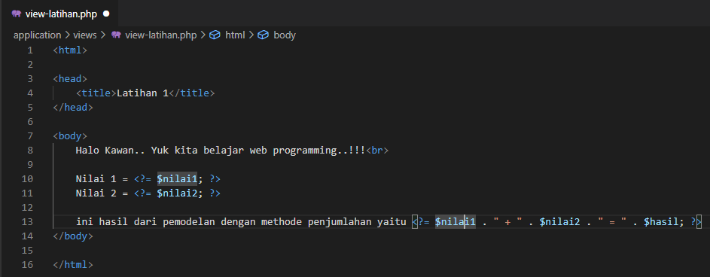

Latihan1.php -> application/controllers

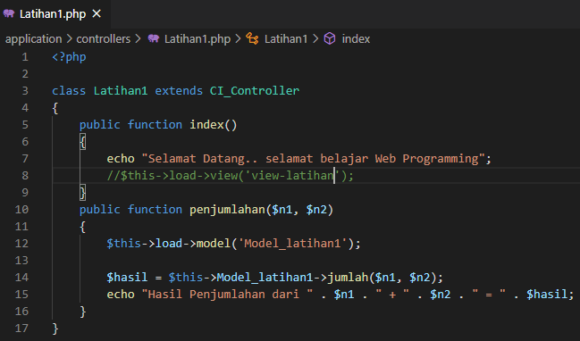

Latihan2.php -> application/controllers

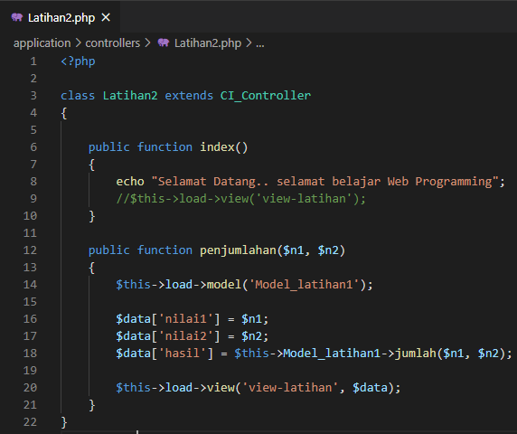

Model_latihan1.php -> application/models

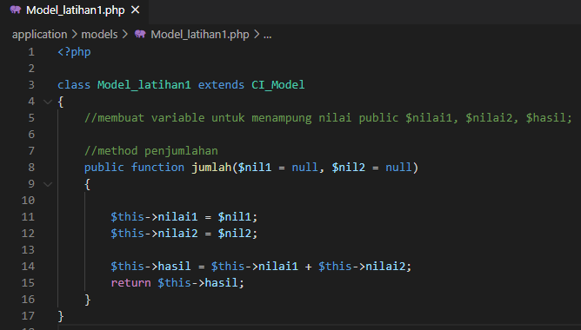

1. Hasil URL

[http://localhost/pustaka-booking/index.php/latihan1](%20http://localhost/pustaka-booking/index.php/latihan1)

<http://localhost/pustaka-booking/index.php/latihan1/penjumlahan/2/5>

<http://localhost/pustaka-booking/index.php/latihan2/penjumlahan/2/1>

1. Capture Hasil

